
TBC1D4(11Y3)Rabbit Monoclonal Antibody
产品详情

产品货号 | 产品名称 | 储存条件 | 保质期
IM68650 | TBC1D4(11Y3)Rabbit Monoclonal Antibody | -20℃ | 1年
产品概述：
产品货号 | IM68650
别名 | AS160;NIDDM5
产品名称 | TBC1D4(11Y3)Rabbit Monoclonal Antibody
类别 | 抗体产品
推荐应用 | WB,IP
反应种属 | Human,Mouse,Rat
存储缓冲液 | Supplied in 50mM Tris-Glycine(pH 7.4),0.15M NaCl,40%Glycerol,0.01% New type preservative N and 0.05% BSA.
稀释度 | WB 1:1000,IP 1:20-1:50
参考分子量 | 160kDa
预测分子量 | 147kDa
性状 | Liquid
运输及保存条件 | Biological ice bag transportation.Store at -20℃ for at least 12 months(Do not lower than 25℃).Avoid freeze/thaw cycles.
宿主 | Rabbit
同种型 | IgG

背景介绍 | This gene is a member of the Tre-2/BUB2/CDC16 domain family.The protein encoded by this gene is a Rab-GTPase-activating protein,and contains two phopshotyrosine-binding domains(PTB1 and PTB2),a calmodulin-binding domain(CBD),a Rab-GTPase domain,and multiple AKT phosphomotifs.This protein is thought to play an important role in glucose homeostasis by regulating the insulin-dependent trafficking of the glucose transporter 4(GLUT4),important for removing glucose from the bloodstream into skeletal muscle and fat tissues.Reduced expression of this gene results in an increase in GLUT4 levels at the plasma membrane,suggesting that this protein is important in intracellular retention of GLUT4 under basal conditions.When exposed to insulin,this protein is phosphorylated,dissociates from GLUT4 vesicles,resulting in increased GLUT4 at the cell surface,and enhanced glucose transport.Phosphorylation of this protein by AKT is required for proper translocation of GLUT4 to the cell surface. Individuals homozygous for a mutation in this gene are at higher risk for type 2 diabetes and have higher levels of circulating glucose and insulin levels after glucose ingestion.Alternative splicing results in multiple transcript variants encoding different isoforms. [provided by RefSeq,Aug 2015].
纯化 | Affinity Purification
Uniprot ID | O60343
Gene ID | 9882
Clonality | Monoclonal

注意事项：
1.我司生产的生化试剂如无特殊标注，基本为非无菌包装，若用于细胞实验，请提前做好预处理。需低温保存的产品，一旦配成溶液，请分装保存，避免反复冻融造成的产品失效。
2.本产品仅限于专业人员的科学研究用，不得用于临床诊断或治疗，不得用于食品或药品，不得存放于普通住宅内。
3.为了您的安全和健康，请穿实验服并戴一次性手套操作。
4.实验结果受多种因素影响，相关处理仅限于产品本身，不涉及其他赔偿。

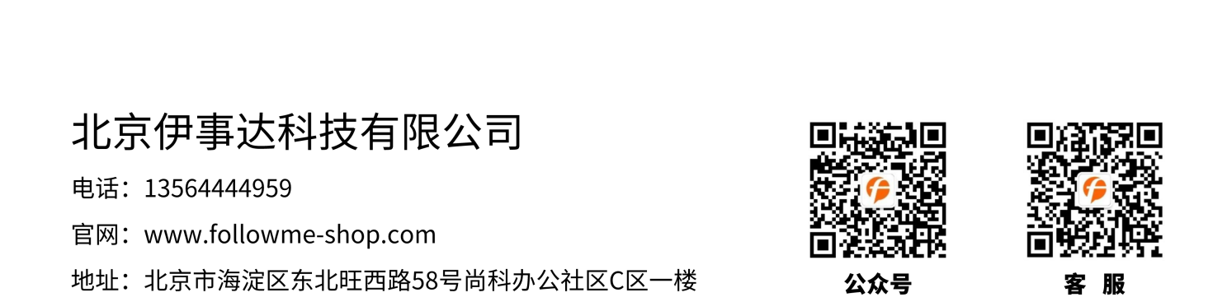
免责声明: 所有产品仅用作科学研究，不得用于其他用途！本公司将不为任何不正常使用此产品时所发生的意外负责。

