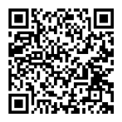
CHOP(9O8)Rabbit Monoclonal Antibody
产品详情

产品货号 | 产品名称 | 储存条件 | 保质期
IM68773 | CHOP(9O8)Rabbit Monoclonal Antibody | -20℃ | 1年
产品概述：
产品货号 | IM68773
别名 | DDIT3
产品名称 | CHOP(9O8)Rabbit Monoclonal Antibody
类别 | 抗体产品
基因名称 | DDIT3
蛋白名称 | DDIT3
推荐应用 | WB,IHC-P,IF-P,IF-F,IF-ICC,ELISA
反应种属 | Human,Mouse,Rat
存储缓冲液 | PBS, 50% glycerol,0.05% Proclin 300,0.05%BSA
Human Gene ID | 1649
Human  Swissprot No. | P35638
Mouse  Swissprot No. | P35639
Rat  Swissprot No. | Q62857

稀释度 | IHC-P 1:100-1:400,WB 1:1000-1:5000,IF-P/IF-F/IF-ICC 1:200-1:1000, ELISA 1:5000-1:20000
参考分子量 | 30kDa
预测分子量 | 19kDa
运输及保存条件 | -20℃/1 year(Do not lower than -25℃)
宿主 | Rabbit
同种型 | Monoclonal,rabbit,IgG,Kappa
背景介绍 | This gene encodes a member of the CCAAT/enhancer-binding protein (C/EBP)family of transcription factors.The protein functions as a dominant-negative inhibitor by forming heterodimers with other C/EBP members,such as C/EBP and LAP(liver activator protein),and preventing their DNA binding activity.The protein is implicated in adipogenesis and erythropoiesis,is activated by endoplasmic reticulum stress,and promotes apoptosis.Fusion of this gene and FUS on chromosome 16 or EWSR1 on chromosome 22 induced by translocation generates chimeric proteins in myxoid liposarcomas or Ewing sarcoma. Multiple alternatively spliced transcript variants encoding two isoforms with different length have been identified.[provided by RefSeq,Aug 2010].
信号通路 | MAPK_ERK_Growth;MAPK_G_Protein
功能 | Disease:A chromosomal aberration involving DDIT3 is found in a form of malignant myxoid liposarcoma[MIM:126337].Translocation t(12;16) (q13;p11)with FUS.function:Inhibits the DNA binding activity of C/EBP and LAP by forming heterodimers that cannot bind DNA. similarity:Belongs to the bZIP family.similarity:Contains 1 bZIP domain.subunit:Heterodimer.

纯化 | Protein A
Clonality | Monoclonal
注意事项：
1.我司生产的生化试剂如无特殊标注，基本为非无菌包装，若用于细胞实验，请提前做好预处理。需低温保存的产品，一旦配成溶液，请分装保存，避免反复冻融造成的产品失效。
2.本产品仅限于专业人员的科学研究用，不得用于临床诊断或治疗，不得用于食品或药品，不得存放于普通住宅内。
3.为了您的安全和健康，请穿实验服并戴一次性手套操作。
4.实验结果受多种因素影响，相关处理仅限于产品本身，不涉及其他赔偿。

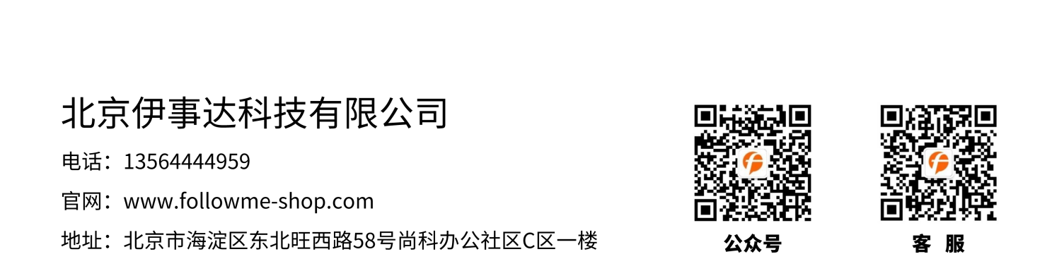
免责声明: 所有产品仅用作科学研究，不得用于其他用途！本公司将不为任何不正常使用此产品时所发生的意外负责。

